**Design Documentation: Helicopter Project Milestone 1**

**Group:**

**Nam Thach**

**Dylan Rush**

**Yachan**

**Introduction**

For the purpose of this milestone, the problem we are trying to solve is a helicopter movement problem. Mainly the power of the throttle of the helicopter. Right now there are only controls that allow the helicopter to increase and decrease rotor speed. We would like the helicopter controls to do more than just that. We would like to have the helicopter to be able to go to 0 throttle immediately and have a neutral control of the throttle where the force of the propeller will be set equal to the force of gravity upon the helicopter. Where if the tilt is 0, then the helicopter would essentially be floating in the air. More Problems will be implementing viscous air friction towards the movement of the helicopter.

**Current Status**

The current state of the helicopter program is that it will allow users to increase and decrease the rotor. Need to implement controls to have a “Neutral mode” and “set rotor to 0”. As well as add extra obstacles to maneuver the helicopter around. The tilt on the helicopter is already set to have a maximum of 15 Degrees; but air viscous is yet to be implemented.

**Team Roles**

Dylan Rush: Implementing extra controls of the helicopter

* Change Rotor Increase and Decrease controls to 1 and 2
* Implement ‘0’ key to reduce the rotor speed to zero
* Implement ‘3’ key to set the rotor to a “neutral mode” where force of rotor will equal, in magnitude, to the force of gravity.
* Design software to make it easy to change specific keys used.

Nam Thach: Change terrain

* Add obstacles to the course
  + Reused balls from milestone warm-up
  + Added dump truck, cow, and spaceship to obstacle course
* Design Document

Yachan:

* Implement Viscous air friction coefficient
* Create new UML models and diagrams

**UML Diagram**

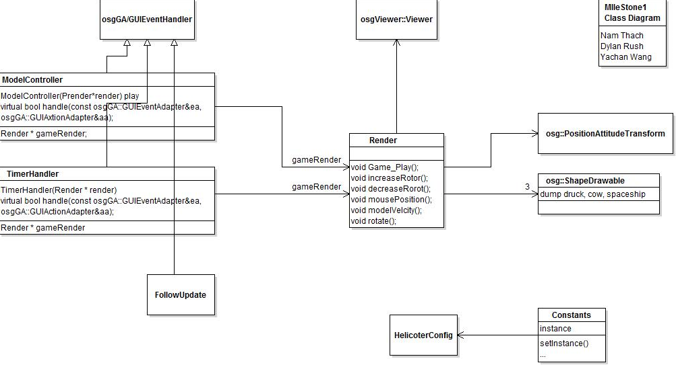

**UML Sequence Diagram**

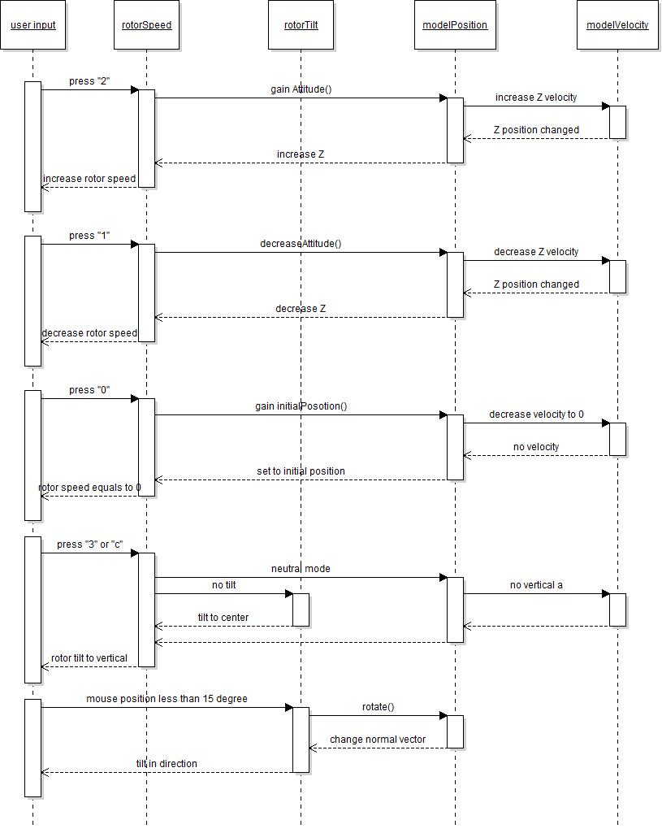

**Summary**

During this milestone we felt good as a group going forward as everyone does there part in a efficient manner. We feel confident going forward, but getting to know OSG and being able to use all of its functionality could prove a bit troublesome. As far as the milestone 1 goes, everyone accomplished what was assigned but bonus functionality was missed to be implemented, for example; collision with the new objects was not implemented as we ran out of time and we were not able to experiment with OSG as much as we would have like.